Project Plan- PantryChef

Group E

Aman Mehta

Nam Nguyen

Kan Yamamoto

Randy Nguyen

Nasser Alsuhaimi

**Project Scope**

PantryChef is an android application designed to aid users utilize the ingredients inside their pantry and refrigerator.

**Project Resources**

* API
  + Spoonacular
  + AmazonFresh
* Required Software
  + Android Studio
  + Github
  + Java Development Kit

**List of Deliverables**

* Documentation

1. Vision Document
2. Project Plan
3. Flowchart / UML
4. Use Cases
5. Test Plan
6. User Manual / UI Layout
7. Database (Tentative)

* Implementation

1. API
2. User Interface
3. Database (Tentative)

**Staff Organization**

* **Aman Mehta**
  + Project Chief
  + Chief of Security
* **Kan Yamamoto**
  + Lead Developer
* **Nasser Alsuhaimi**
  + Chief of Interface Implementation
* **Nam Nguyen**
  + Chief of Quality Control
* **Randy Nguyen**
  + Database Specialist

**Agile Development**

* ***Individuals and Interactions:*** *More than processes and tools*
  + Make sure UI is clean and user friendly
* ***Working Software:*** *More than comprehensive documentation*
  + Although there will be clear documentation, the team’s primary focus is to push out the product as soon as possible.
* ***Customer Collaboration:*** *More than contract negotiation*
  + Attract customers with version 1.0 of PantryChef and improve/add features according to feedback (Through app comments and Reported bugs).
* ***Responding to Change:*** *More than following a plan*
  + The team will be able to adapt to time constraints and will be able to add and remove features according to design choice.

**Project Schedule**

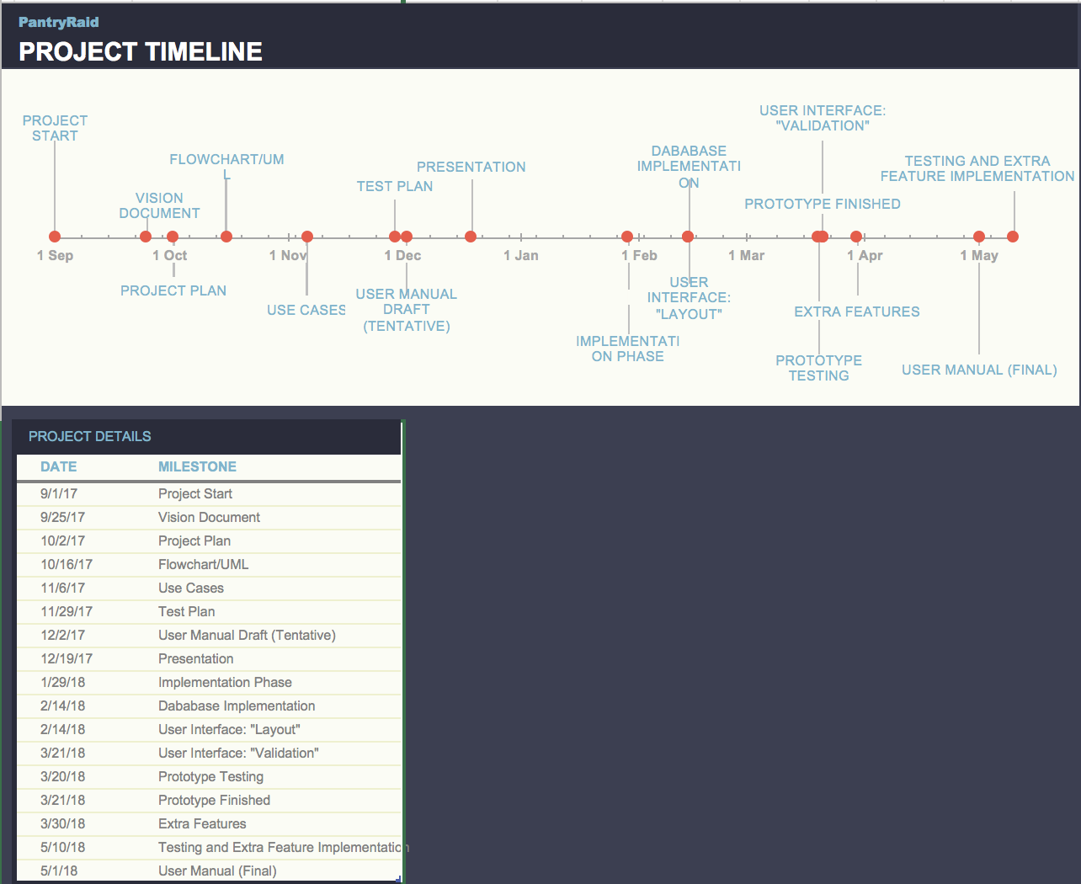

**Documentation Phase**

**Vision Document**

* **ETA: September 25th, 2017**
* Vision Document is an overview of the program and the purpose of it.

**Project Plan**

* **ETA: October 2nd, 2017**
* This document is a project timeline and lists the deliverables due at each deadline. There is a small summary for each deliverable.

**Flowchart / UML**

* **ETA: October 16th, 2017**
* A flowchart and UML model of the layout and design of the project.

**Use Cases**

* **ETA: November 6th, 2017**
* A document detailing the possible use cases that can occur during the program’s execution.

**Test Plan**

* **ETA: November 29th, 2017**
* A document detailing the methods that will be used to test our code to ensure functionality and that the program meets all of the stakeholder’s requirements.

**User Manual Draft (Tentative)**

* **ETA: TBD (December 2nd, 2017)**
* A reference guide for the end-users of the product that explains the how to use the app and how the app is sending data to the user. Also it explains the user interface.

**Presentation Due**

* **ETA: December 13th, 2017 - December 19th, 2017**
* Product presentation to investors is due during this time period. Presentation will be delivered with powerpoint.

**--End of Documentation Phase--**

**Implementation Phase**

**API Implementation**

* **ETA: January 22nd, 2018 - January 29th, 2018**
* The time period dedicated to understanding all the tools to be utilized in the app. This includes Spoonacular and AmazonFresh.

**Database Implementation**

* **ETA: January 22nd, 2018 - February 14th, 2018**
* Implementing the database for storing what is in a user’s refrigerator or pantry.
* Database will contain: Favorites, groceries list, ratings

**User Interface: Part One “Layout”**

* **ETA: February 14th, 2018**
* User interface layout is just the design part. Meaning how the program/game will look like.

**User Interface: Part Two “Validation”**

* **ETA: March 21st, 2018**
* User interface validation is the actual working interface. So we will be able to pull up recipe and use the various functions.

**Prototype Testing**

* **ETA: March 1st, 2018 - March 20th, 2018**
* Main feature testing
* Check for bugs in main features

**Prototype Finished**

* **ETA: March 21st, 2018**
* End-users will be able to perform basic functions in the app, such as pulling up recipes and storing ingredients.
* Expected Features: Recipes, Input from users, API must work, expiration date

**Extra Features**

* **ETA: March 30th, 2018**
* Expected Features: Barcode scanner, AmazonFresh and other ideas.
* Depending on time constraints, the team may add one or more extra features to enhance app capabilities
* Depending on the progress of project this time maybe waived if behind schedule or used to discuss possible addition of features

**Testing and Extra Features Implementation**

* **ETA: April 1st, 2018 - May (Finals day)**
* Rigorous testing for bugs, security, and make code more robust.
* Add extra features if time allows

**User Manual (Final)**

* **ETA: May 1st, 2018**
* Create a finalized user manual to accompany app

**PantryChef v1.0 Launch Day**

* **ETA: May 1st, 2018**